**AttendEase:** Facial Recognition Attendance system

### Project Proposal

## 

## HU logo High Resolution.png

## Supervisor

Muntaha Mehboob

## Co-Supervisor

Afzal Hussain

## Submitted by

Imran Ali

{1394-2021 / IT-21-335}

M.Umer Saleem

{2261-2021 / IT-21-329}

M.Adil shaikh

{2345-2021 / IT-21-327}

**Department of Computer Science,**

Hamdard University, Karachi.

[27-06-2024]

# Introduction

In an era where technology permeates every aspect of our lives, attendance management systems are no exception. Our proposed Smart Attendance System aims to enhance traditional attendance tracking by harnessing the power of facial recognition technology.

Develop algorithms to recognize faces accurately from both photos and videos. This involves feature extraction, deep learning models, and efficient matching techniques. Implement a real-time monitoring system that continuously processes video streams and updates attendance records promptly. Create an application that seamlessly integrates with existing attendance management systems. Staff can use the app to mark student attendance and view student records. Design an intuitive interface for end-users. The application should be easy to navigate, allowing individuals to check their attendance status effortlessly. Prioritize data security by encrypting sensitive information and ensuring compliance with privacy regulations. Protect user identities and attendance records. Provide administrators with detailed attendance reports and analytics.

# Objective

* **Develop Robust Facial Recognition Algorithms:**
  + Design and implement algorithms capable of recognizing faces with high accuracy from both photos and videos.
  + Integrate advanced feature extraction methods and deep learning models for precise identification.
* **Seamless Integration with Existing Systems:**
  + Develop an application that can be easily integrated with current attendance management systems.
  + Allow staff to mark attendance and manage student records through the application.
* **User-Friendly Application Interface:**
  + Design an intuitive and navigable interface for the end-users.
  + Enable users to check their attendance status quickly and efficiently.
* **Prioritize Data Security and Privacy:**
  + Encrypt sensitive information to safeguard user identities and attendance data.
  + Ensure the system complies with all relevant privacy regulations and standards.
* **Provide Comprehensive Reporting and Analytics:**
  + Offer detailed attendance reports and analytics for administrators.
  + Support data-driven decision-making with actionable insights into attendance trends.

These objectives aim to address the key aspects of accuracy, efficiency, user experience, and security within the project scope.

# Problem Description

In the world of educational institutions, maintaining accurate and efficient attendance records is crucial. The traditional methods of marking attendance are time-consuming and prone to human error. The challenge lies in developing a sophisticated facial recognition system that can accurately identify individuals from both still images and live video feeds. This system must be capable of real-time processing to update attendance records instantaneously.

The project will involve the creation of advanced algorithms for facial recognition, incorporating feature extraction, the application of deep learning models, and the development of efficient matching techniques. A significant aspect of the project is the implementation of a real-time monitoring system that processes video streams continuously, ensuring prompt updates to attendance records.

Furthermore, the project aims to develop an application that integrates seamlessly with pre-existing attendance management systems. This application will enable staff to mark student attendance and access student records with ease. An essential requirement for the application is an intuitive user interface that allows both staff and students to navigate the system effortlessly, enabling users to check their attendance status with minimal interaction.

Data security is of paramount importance; hence, the project must prioritize the encryption of sensitive information and adhere to stringent privacy regulations to protect the identities and attendance records of users. Additionally, the system should provide administrators with comprehensive attendance reports and analytics, offering insights into attendance patterns and enabling data-driven decision-making.

This project seeks to revolutionize attendance management by combining accuracy, efficiency, and security, thereby streamlining the process for educational institutions.

# Methodology

The evolving prototype, which focuses on developing an initial version of the system and then continually modifying and enhancing it based on feedback and new requirements, is the most suitable option for the facial attendance system. Enhancing communication, responsiveness, usability, and user interaction are its main points of emphasis.

Evolutionary prototyping will enable us to develop a system that is user-friendly, responsive to user feedback, and can be used to streamline the hiring process. This will enable us to meet the needs of both faculty and admissions staff while also making ongoing improvements to the system.

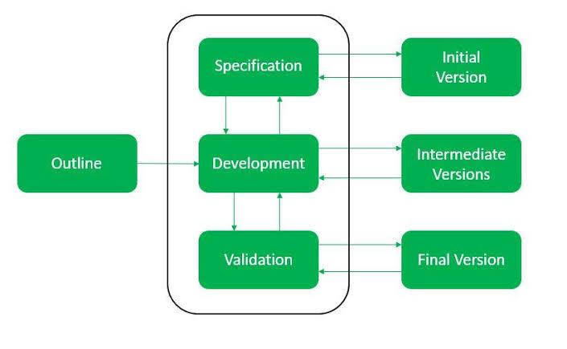

# Project Scope

To create an advanced attendance management system, accurate face recognition algorithms are developed for both photos and videos, leveraging feature extraction, deep learning models, and efficient matching techniques. The system includes real-time monitoring that continuously processes video streams, promptly updating attendance records. It integrates seamlessly with existing attendance management systems, allowing staff to mark attendance, view records, and send notifications to parents. A user-friendly interface makes checking attendance status effortless for end-users. Data security is prioritized by encrypting sensitive information and ensuring compliance with privacy regulations to protect user identities and attendance records. Additionally, the system provides detailed attendance reports and analytics for administrators.

# Feasibility Study

* + 1. **Risks Involved**:
* As Misidentification due to lighting, posture, or picture quality:  
  Utilize high-quality pictures, set certainty edges, and routinely overhaul the database.
* Encroachment on security rights:  
  Convey frameworks in controlled situations, comply with protection controls, and advise clients almost information collection.
* Overconfidence in facial acknowledgment:  
  Combine facial acknowledgment with other confirmation strategies and secure databases.

.

* + 1. **Resource Requirement**:

**PROCESSOR:** CORE i5 5th Generation or higher

**RAM:** 8GB or higher

**INTERNET:** 12MB connection or FIBER OPTICS

# Solution Application Areas

The Facial recognition attendance systems holds significant value especially for those industries like educational institutions (schools, colleges, universities), Healthcare facilities, Access Control and Security. Facial recognition technology offers numerous benefits in educational and organizational settings. It saves instructional time, enhances student engagement, and provides real-time attendance insights. By reducing infection risk and streamlining shift management, it ensures accurate records and operational efficiency. Additionally, it enhances security by verifying identities and preventing unauthorized entry, creating a safer and more efficient environment.

# Tools/Technology

**Backend:** OpenCV, Dlip, tensorflow, PyTorch

**Frontend:** Flutter

**SOFTWARE**:

* IDE
* VSCODE
* MS SQL
* Google Colab/ Jupyter

# Responsibilities of the Team Members

|  |  |  |  |  |
| --- | --- | --- | --- | --- |
| Project Deliverable  Activity | Imran Ali | M. Umer Saleem | M. Adil Shaikh | Supervisor |
| Project Planning | **R** | **R,A** | **R** | **C, I** |
| Project Analysis | **R** | **R** | **A** | **C, I** |
| Project Design | **A** | **R** | **R** | **C, I** |
| Project Implementation | **R,A** | **R** | **R** | **C, I** |
| Project Documentation | **R** | **R,A** | **R** | **C, I** |
| Finalize and Deployment | **R,A** | **R** | **A** | **C, I** |

# 10. Planning

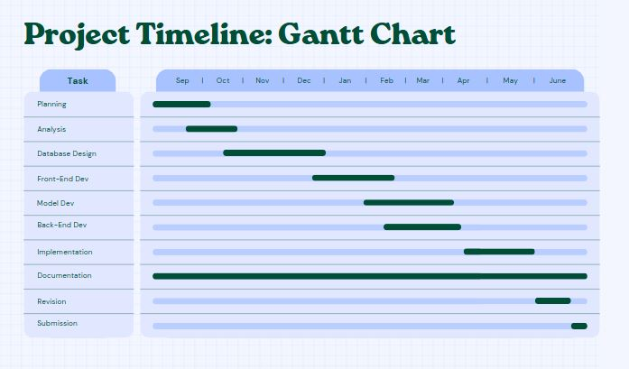

# 11. References

* Hao Yang and Xiaofeng Han “Face Recognition Attendance System Based on ReRal-time Video Processing” in proc, IEEE Access
* Nirmalya Kar, Mrinal Kanti Debbarma, Ashim Saha, and Dwijen Rudra Pal “ Study of Implementing Automated Attendance System Using Face Recognition Technique” in proc, International Journal of Computer and Communication Engineering, Vol. 1
* P.Sinha, B.Balas, Y.Ostrovsky, and R.Russell, “Face Recognition by Humans: Nineteen Results All Computer Vision Researchers Should Know About,”inProceedings of the IEEE, vol. 94, Issue11, 2006.